Assessment 4: HTML, CSS and Design

Flying Taxi Website Design

Intro to the Web - ITC293

By: Loren Nimmo (ID: 11785096)

Due: 08/06/2025

Table of Contents:

Concept Map 3

CSS Design 4

Homepage 4

About Page 4

Resume Page 4

Web Skills Page 4

Navigation Map (Logical) 5

Structure Chart (Physical) 6

Storyboards 7

Homepage 7

About Page 7

Resume Page 7

Web Skills Page 7

Requirements (HTML and CSS) 8

Testing Plan 9

Browser compatibility: 9

Navigation Links: 9

Print Friendly: 9

Responsiveness: 10

Validation: 10

Reflection on Changes 11

References 12

## Concept Map

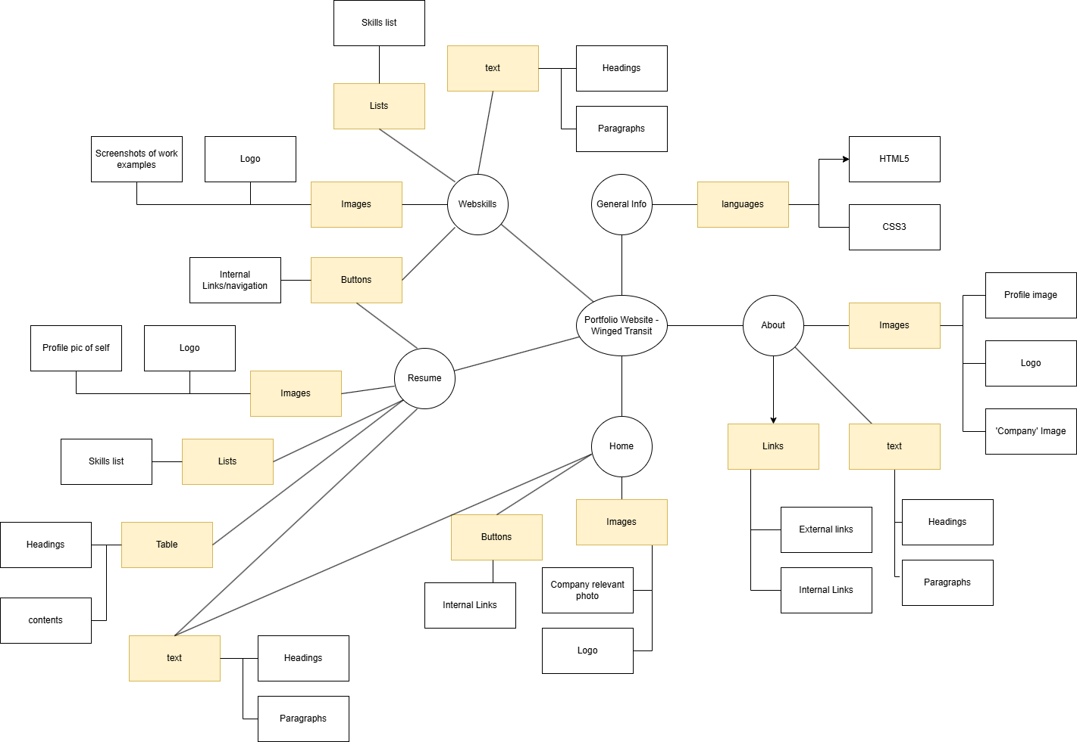

UPDATE AFTER GETTING 1ST ASSIGNMENT FEEDBACK

## CSS Design

### Homepage

### About Page

### Resume Page

### Web Skills Page

## Navigation Map (Logical)

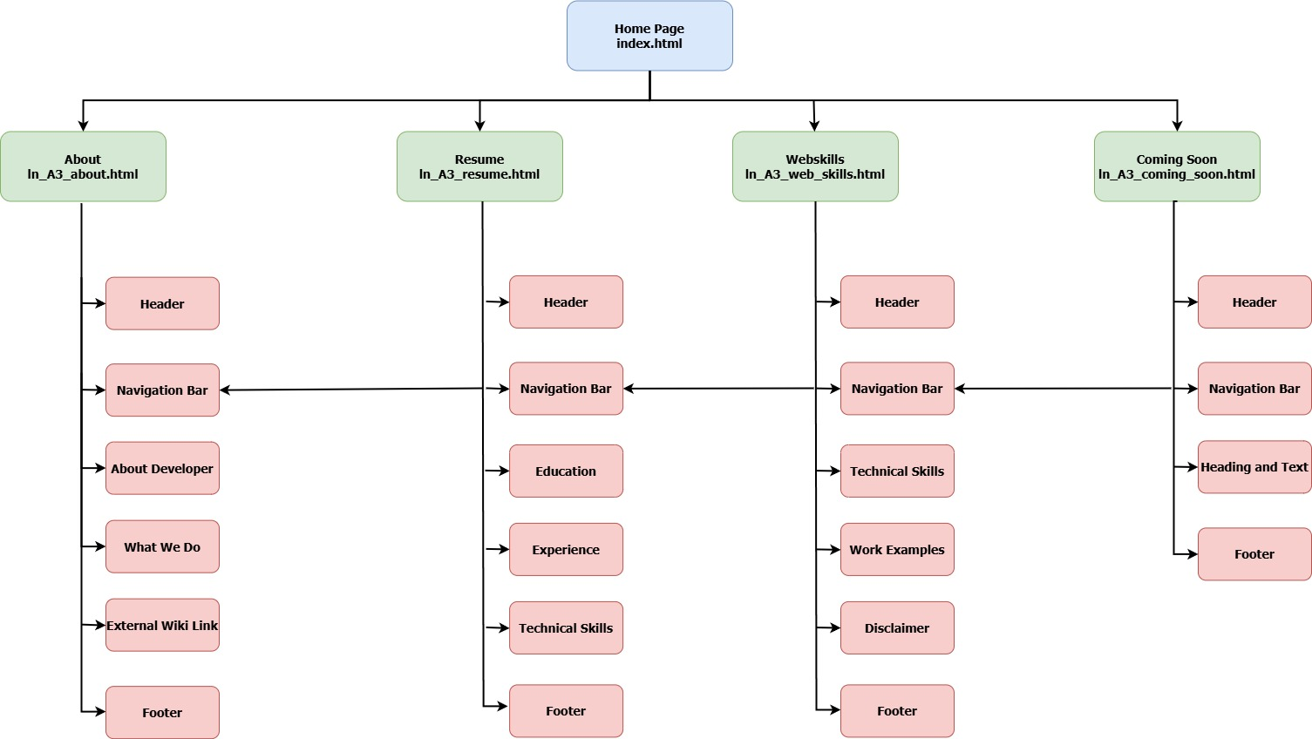

## Structure Chart (Physical)

LorenNimmo11785096A3

├── index.html

├── ln_A3_about.html

├── ln_A3_coming_soon.html

├── ln_A3_enquire.html

├── ln_A3_resume.html

├── ln_A3_submit_form.html

├── ln_A3_web_skills.html

├── css

│ └── portfolio.css

└── images

└── logo.png

└── founder.jpg

└── example1.png

└── example2.png

└── example3.png

└── example4.png

└── flyingtaxi1.jpg

└── etc.

## Storyboards

### Homepage

### About Page

### Resume Page

### Web Skills Page

## Requirements (HTML and CSS)

**HTML:**

|  |  |
| --- | --- |
|  |  |
|  |  |
|  |  |
|  |  |
|  |  |
|  |  |
|  |  |
|  |  |
|  |  |
|  |  |
|  |  |
|  |  |

**CSS:**

|  |  |
| --- | --- |
|  |  |
|  |  |
|  |  |
|  |  |
|  |  |
|  |  |
|  |  |
|  |  |
|  |  |
|  |  |

## Testing Plan

The following is a list of key areas where essential testing should take place for the website:

### Browser compatibility:

Tested on multiple browsers:

* Chrome

[SCRENSHOT HERE]

* Firefox

[SCRENSHOT HERE]

* Safari

[SCRENSHOT HERE]

### Navigation Links:

All pages were thoroughly tested and checked for broken links:

[VIDEO HERE]

### Print Friendly:

Used Ctrl+P to confirm that header, nav, and footer are hidden, and colours are removed:

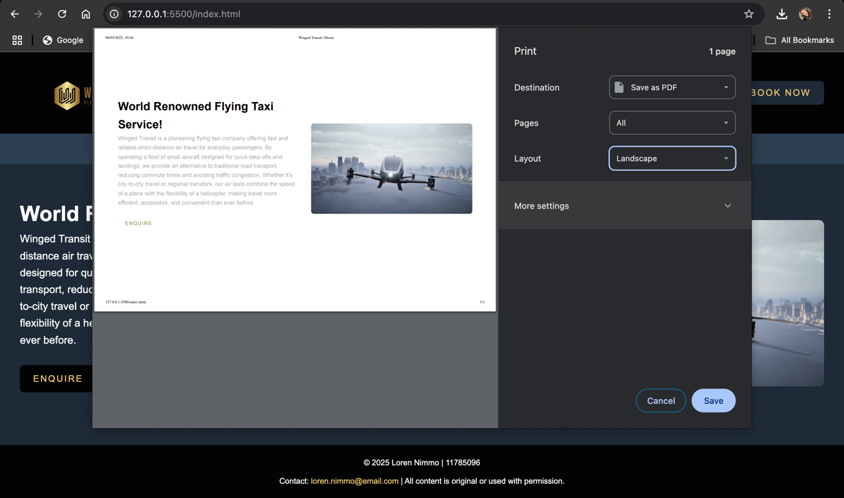

### Responsiveness:

The website can be tested for responsiveness by navigating the site quickly, to check the speed at which the site responds.

### Validation:

Used W3C Validator for all HTML and CSS, this can be utilised after each iteration to ensure no errors have been introduced.

[SCREENSHOTS HERE]

## Reflection on Changes

In A3, I removed all internal and inline CSS and migrated styles into the external portfolio.css file. I improved button styling using consistent classes, updated navigation buttons to be CSS-styled across all pages and added print-friendly rules. I also replaced the unordered list on the resume page with a table showing my core subjects, fulfilling the table requirement. I also replaced the sample/placeholder text with real text per the feedback provided from the previous assignment. I also replaced some of the coming soon pages with real pages. While no strictly necessary, I wanted to add more to the website, as I’d already done most of the ‘new’ assignment 3 requirements in my first iteration of the site.

Fixed an issue with the navigation bar which resulted in the | symbol between words being also highlighted when hovering over an option.

ADD MENTION OF IMPROVEMENTS BASED ON FEEDBACK HERE.

## References

Bianchi, F. (2024). *Coolors – The super fast color palettes generator!*.<https://coolors.co/>

Canva. (n.d.). *Canva: Visual suite for everyone*.<https://www.canva.com>

Cornell Learning Strategies Center. (n.d.). *Concept maps*.<https://lsc.cornell.edu/how-to-study/concept-maps/>

iStock. (n.d.). *Autonomous driverless aerial vehicle fly across city [Stock photo]*.<https://media.istockphoto.com/id/1394560526/photo/autonomous-driverless-aerial-vehicle-fly-across-city-3d-render.jpg?s=612x612&w=0&k=20&c=ueYQDrWQqSh4WRqto1vg5Pu2FdHul4B1m6lTuYWX1pE=>

Vecteezy. (n.d.). *Beautiful woman red hair avatar character icon [Vector image]*.<https://static.vecteezy.com/system/resourcezs/previews/003/346/361/non_2x/beautiful-woman-red-hair-avatar-character-icon-free-vector.jpg>

W3C. (n.d.). *The W3C Markup Validation Service*. https://validator.w3.org/

<https://www.istockphoto.com/photos/sales-and-marketing>